**Nama : Wildan Sania Alfiansyah  
NIM : 18090118  
Kelas : 5C**

1. **Source Code**

Web.php -> application/controllers

v_header.php -> application/views

v_footer.php -> application/views

v_index .php -> application/views

v_about.php -> application/views

stylebuku.css -> assets/css

1. **URL**

http://localhost/pustaka_wildan /Web

http://localhost/pustaka_wildan /Web/about

1. **Capture Hasil**

**Web**

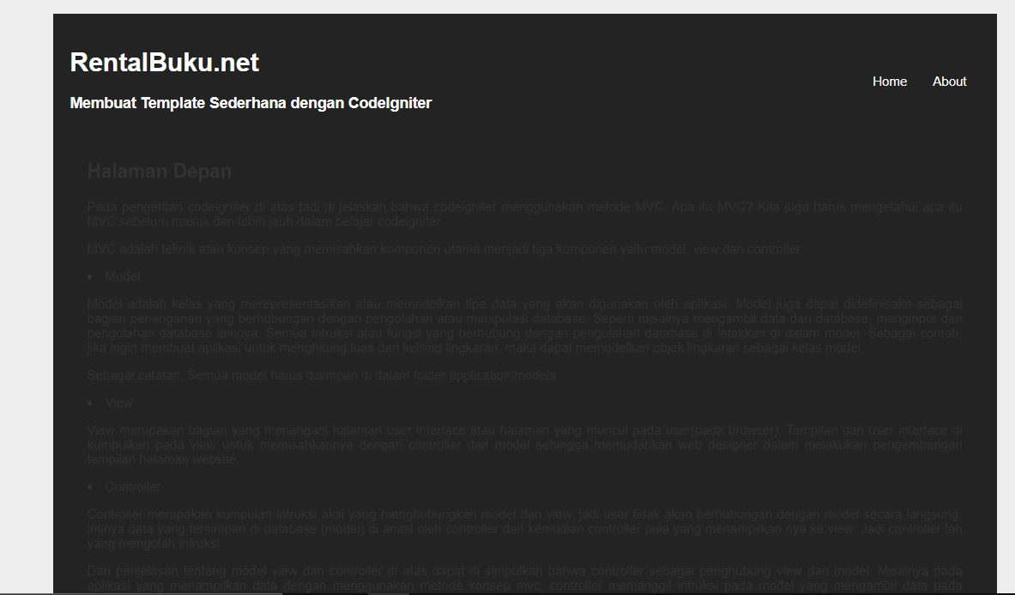

**About**

